**Module 4 introduction**

**Learning objectives**

In this module, you will learn how to:

* Describe the basic concepts of networking.
* Describe the difference between public and private networking resources.
* Explain a virtual private gateway using a real life scenario.
* Explain a virtual private network (VPN) using a real life scenario.
* Describe the benefit of AWS Direct Connect.
* Describe the benefit of hybrid deployments.
* Describe the layers of security used in an IT strategy.
* Describe the services customers use to interact with the AWS global network.

Video Transcript

If we think back to our coffee shop or AWS account, things by now should be running smoothly. Although, what if we had a few eager customers who wanted to give their orders directly to the baristas instead of the cashier out in front? Well, it doesn't make sense to allow every customer to be able to interact with our baristas since they are focused on brewing some fresh caffeinated beverages. So what do we do?

That's right, kids, say it with me, Amazon Virtual Private Cloud, or VPCs, as they're affectionately known. A VPC lets you provision a logically isolated section of the AWS Cloud where you can launch AWS resources in a virtual network that you define. These resources can be public facing so they have access to the internet, or private with no internet access, usually for backend services like databases or application servers. The public and private grouping of resources are known as subnets and they are ranges of IP addresses in your VPC.

Now, in our coffee shop, we have different employees and one is a cashier. They take customers' orders and thus we want customers to interact with them, so we put them in what we call a public subnet. Hence they can talk to the customers or the internet. But for our baristas, we want them to focus on making coffee and not interact with customers directly, so we put them in a private subnet.

Okay, let's get into the next video where we'll dive into networking.

# Connectivity to AWS

**Video transcript**

–

A VPC, or Virtual Private Cloud, is essentially your own private network in AWS. A VPC allows you to define your private IP range for your AWS resources, and you place things like EC2 instances and ELBs inside of your VPC.

Now you don't just go throw your resources into a VPC and move on. You place them into different subnets. Subnets are chunks of IP addresses in your VPC that allow you to group resources together. Subnets, along with networking rules we will cover later, control whether resources are either publicly or privately available. What we haven't told you yet is there are actually ways you can control what traffic gets into your VPC at all. What I mean by this is, for some VPCs, you might have internet-facing resources that the public should be able to reach, like a public website, for example.

However, in other scenarios, you might have resources that you only want to be reachable if someone is logged into your private network. This might be internal services, like an HR application or a backend database. First, let's talk about public-facing resources. In order to allow traffic from the public internet to flow into and out of your VPC, you must attach what is called an internet gateway, or IGW, to your VPC.

An internet gateway is like a doorway that is open to the public. Think of our coffee shop. Without a front door, the customers couldn't get in and order their coffee, so we install a front door and the people can then go in and out of that door when coming and going from our shop. The front door in this example is like an internet gateway. Without it, no one can reach the resources placed inside of your VPC.

Next, let's talk about a VPC with all internal private resources. We don't want just anyone from anywhere to be able to reach these resources. So we don't want an internet gateway attached to our VPC. Instead, we want a private gateway that only allows people in if they are coming from an approved network, not the public internet. This private doorway is called a virtual private gateway, and it allows you to create a VPN connection between a private network, like your on-premises data center or internal corporate network to your VPC.

To relate this back to the coffee shop, this would be like having a private bus route going from my building to the coffee shop. If I want to go get coffee, I first must badge into the building, thus authenticating my identity, and then I can take the secret bus route to the internal coffee shop that only people from my building can use. So if you want to establish an encrypted VPN connection to your private internal AWS resources, you would need to attach a virtual private gateway to your VPC.

Now the problem with our super secret bus route is that it still uses the open road. It's susceptible to traffic jams and slowdowns caused by the rest of the world going about their business. The same thing is true for VPN connections. They are private and they are encrypted, but they still use a regular internet connection that has bandwidth that is being shared by many people using the internet.

So what I've done to make things more reliable and less susceptible to slowdowns is I made a totally separate magic doorway that leads directly from the studio into the coffee shop. No one else driving around on the road can slow me down because this is my direct doorway; no one else can use it. What, did you not have a secret magic doorway into your favorite coffee shop? All right, moving on. The point being is you still want a private connection, but you want it to be dedicated and shared with no one else. You want the lowest amount of latency possible with the highest amount of security possible.

With AWS, you can achieve that using what is called AWS Direct Connect. Direct Connect allows you to establish a completely private, dedicated fiber connection from your data center to AWS. You work with a Direct Connect partner in your area to establish this connection, because like my magic doorway, AWS Direct Connect provides a physical line that connects your network to your AWS VPC. This can help you meet high regulatory and compliance needs, as well as sidestep any potential bandwidth issues. It's also important to note that one VPC might have multiple types of gateways attached for multiple types of resources all residing in the same VPC, just in different subnets.

Thanks for listening. I'm gonna sit here and keep ordering coffees from my magic door. See ya.

**Amazon Virtual Private Cloud (Amazon VPC)**

Imagine the millions of customers who use AWS services. Also, imagine the millions of resources that these customers have created, such as Amazon EC2 instances. Without boundaries around all of these resources, network traffic would be able to flow between them unrestricted.

A networking service that you can use to establish boundaries around your AWS resources is [**Amazon Virtual Private Cloud (Amazon VPC)**](https://aws.amazon.com/vpc/).

Amazon VPC enables you to provision an isolated section of the AWS Cloud. In this isolated section, you can launch resources in a virtual network that you define. Within a virtual private cloud (VPC), you can organize your resources into subnets. A **subnet** is a section of a VPC that can contain resources such as Amazon EC2 instances.

**Internet gateway**

To allow public traffic from the internet to access your VPC, you attach an **internet gateway** to the VPC.

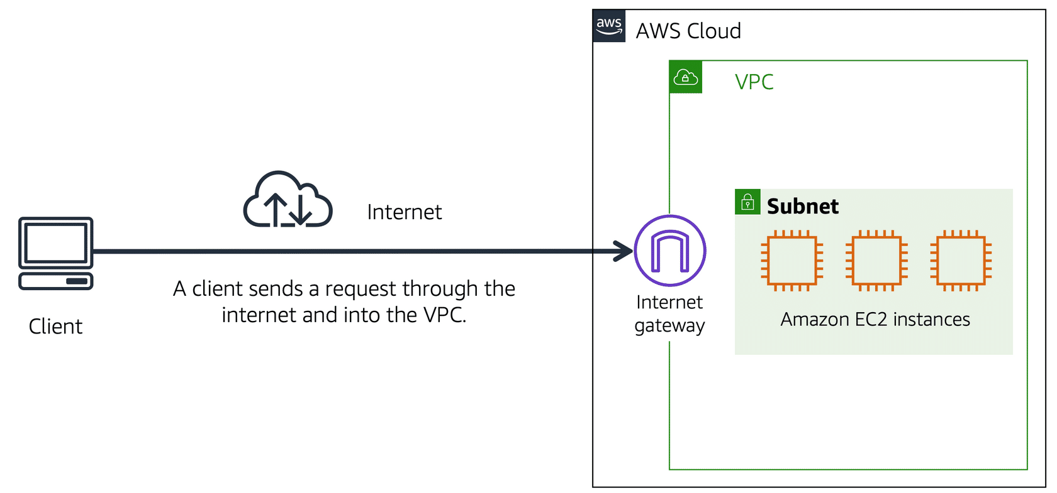

An internet gateway is a connection between a VPC and the internet. You can think of an internet gateway as being similar to a doorway that customers use to enter the coffee shop. Without an internet gateway, no one can access the resources within your VPC.

What if you have a VPC that includes only private resources?

**Virtual private gateway**

To access private resources in a VPC, you can use a **virtual private gateway**.

Here’s an example of how a virtual private gateway works. You can think of the internet as the road between your home and the coffee shop. Suppose that you are traveling on this road with a bodyguard to protect you. You are still using the same road as other customers, but with an extra layer of protection.

The bodyguard is like a virtual private network (VPN) connection that encrypts (or protects) your internet traffic from all the other requests around it.

The virtual private gateway is the component that allows protected internet traffic to enter into the VPC. Even though your connection to the coffee shop has extra protection, traffic jams are possible because you’re using the same road as other customers.

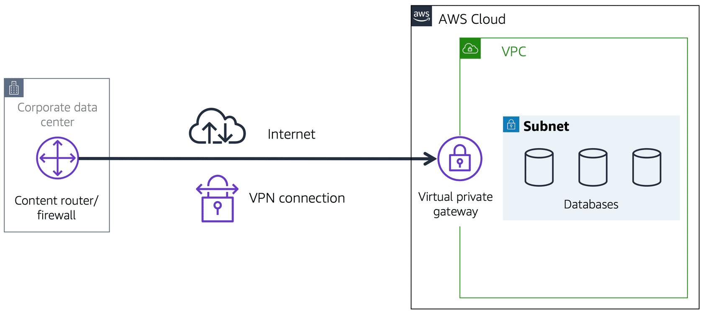

A virtual private gateway enables you to establish a virtual private network (VPN) connection between your VPC and a private network, such as an on-premises data center or internal corporate network. A virtual private gateway allows traffic into the VPC only if it is coming from an approved network.

**AWS Direct Connect**

[**AWS Direct Connect**](https://aws.amazon.com/directconnect/) is a service that enables you to establish a dedicated private connection between your data center and a VPC.

Suppose that there is an apartment building with a hallway directly linking the building to the coffee shop. Only the residents of the apartment building can travel through this hallway.

This private hallway provides the same type of dedicated connection as AWS Direct Connect. Residents are able to get into the coffee shop without needing to use the public road shared with other customers.

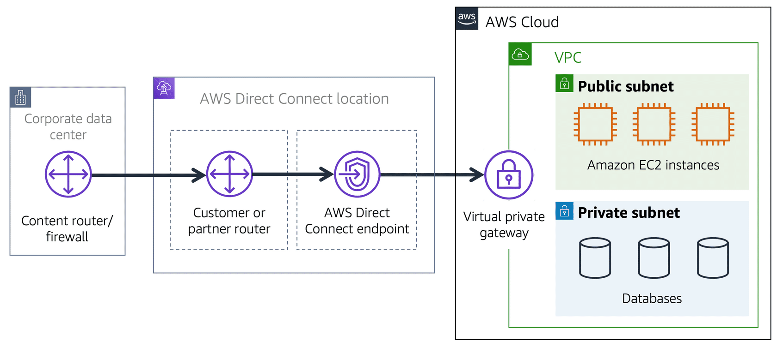

The private connection that AWS Direct Connect provides helps you to reduce network costs and increase the amount of bandwidth that can travel through your network.

# Subnets and network access control lists

**Video transcript**

–

Welcome to your VPC. You can think of it as a hardened fortress where nothing goes in or out without explicit permission. You have a gateway on the VPC that only permits traffic in or out of the VPC. But that only covers perimeter, and that's only one part of network security that you should be focusing on as part of your IT strategy.

AWS has a wide range of tools that cover every layer of security: network hardening, application security, user identity, authentication and authorization, distributed denial-of-service or DDoS prevention, data integrity, encryption, much more. We're gonna talk about a few of these key pieces. And if you really wanna know more about security, please follow the links in this page to be directed to more information and additional training on how to lock your infrastructure down tighter than Aunt Robin's secret lemon pie recipe, and ain't nobody getting that recipe.

Today, I wanna talk about a few aspects of network hardening looking at what happens inside the VPC. Now, the only technical reason to use subnets in a VPC is to control access to the gateways. The public subnets have access to the internet gateway; the private subnets do not. But subnets can also control traffic permissions. Packets are messages from the internet, and every packet that crosses the subnet boundaries gets checked against something called a network access control list or network ACL. This check is to see if the packet has permissions to either leave or enter the subnet based on who it was sent from and how it's trying to communicate.

You can think of network ACLs as passport control officers. If you're on the approved list, you get through. If you're not on the list, or if you're explicitly on the do-not-enter list, then you get blocked. Network ACLs check traffic going into and leaving a subnet, just like passport control. The list gets checked on your way into a country and on the way out. And just because you were let in doesn't necessarily mean they're gonna let you out. Approved traffic can be sent on its way, and potentially harmful traffic, like attempts to gain control of a system through administrative requests, they get blocked before they ever touch the target. You can't hack what you can't touch.

Now, this sounds like great security, but it doesn't answer all of the network control issues. Because a network ACL only gets to evaluate a packet if it crosses a subnet boundary, in or out. It doesn't evaluate if a packet can reach a specific EC2 instance or not. Sometimes, you'll have multiple EC2 instances in the same subnet, but they might have different rules around who can send them messages, what port those messages are allowed to be sent to. So you need instance level network security as well.

To solve instance level access questions, we introduce security groups. Every EC2 instance, when it's launched, automatically comes with a security group. And by default, the security group does not allow any traffic into the instance at all. All ports are blocked; all IP addresses sending packets are blocked. That's very secure, but perhaps not very useful. If you want an instance to actually accept traffic from the outside, like say, a message from a front end instance or a message from the Internet. So obviously, you can modify the security group to accept a specific type of traffic. In the case of a website, you want web-based traffic or HTTPS to be accepted but not other types of traffic, say an operating system or administration requests.

If NACLs are a passport control, a security group is like the doorman at your building, the building being the EC2 Instance, in this case. The doorman will check a list to ensure that someone is allowed to enter the building but won't bother check the list on the way out. With security groups, you allow specific traffic in and by default, all traffic is allowed out. Now, wait a minute, Blaine. You just described two different engines each doing the exact same job. Let good packets in, keep bad packets out. The key difference between a security group and a network ACL is the security group is stateful, meaning, as we talked about, it has some kind of a memory when it comes to who to allow in or out, and the network ACL is stateless, which remembers nothing and checks every single packet that crosses its border regardless of any circumstances.

You know, this metaphor is important to understand. So I wanna illustrate the round trip of a packet as it goes from one instance to another instance in a different subnet. Now, this traffic management, it doesn't care about the contents of the packet itself. In fact, it doesn't even open the envelope, it can't. All it can do is check to see if the sender is on the approved list.

All right. Let's start with instance A. We wanna send a packet from instance A to instance B in a different subnet, same VPC, different subnets. So instance A sends the packet. Now, the first thing that happens is that packet meets the boundary of the security group of instance A. By default, all outbound traffic is allowed from a security group. So you can walk right by the doormen and leave, cool, right. The packet made it past the security group of instance A. Now it has to leave the subnet boundary. At the boundary, the passport must now make it through passport control, the network ACL. The network ACL doesn't care about what the security group allowed. It has its own list of who can pass and who can't. If the target address is allowed, you can keep going on your journey, which it is.

So now we have exited the original subnet and now the packet goes to the target subnet where instance B lives. Now at this target subnet, once again, we have passport control. Just because the packet was allowed out of its home country does not mean that it can enter the destination country or subnet in this case. They both have unique passport officers with their own checklists. You have to be approved on both lists, or you could get turned away at the border. Well, turns out the packet is on the approved list for this subnet, so it's allowed to enter through the network ACL into the subnet. Almost there. Now, we're approaching the target instance, instance B. Every EC2 Instance has their own security group. You wanna enter this instance, the doorman will need to check to see if you're allowed in, and we're on the list. The packet has reached the target instance.

Once the transaction's complete, now it's just time to come home. It's the return traffic pattern. It's the most interesting, because this is where the stateful versus stateless nature of the different engines come into play. Because the packet still has to be evaluated at each checkpoint. Security groups, by default, allow all return traffic. So they don't have to check a list to see if they're allowed out. Instead, they automatically allow the return traffic to pass by no matter what. Passport control here at the subnet boundary, these network ACLs do not remember state. They don't care that the packet came in here. It might be on a you-can't-leave list. Every ingress and egress is checked with the appropriate list. The package return address has to be on their approved list to make it across the border. Made it to the border of the origin subnet, but we have to negotiate passport network ACL control here as well. Stateless controls, means it always checks its list.

The packet pass the network ACL, the subnet level, which means the packets now made it back to instance A but the security group, the doorman is still in charge here. The key difference though is these security groups are stateful. The security group recognizes the packet from before. So it doesn't need to check to see if it's allowed in. Come on home.

Now, this may seem like we spent a lot of effort just getting a packet from one instance to another and back. You might be concerned about all the network overhead this might generate. The reality is all of these exchanges happen instantly as part of how AWS Networking actually works. If you wanna know the technology that makes all that possible, well, then you need to sign up for a completely different set of trainings. Good network security will take advantage of both network ACLs and security groups, because security in-depth is critical for modern architectures.

To learn more about the role of subnets within a VPC, review the following example from the coffee shop.

First, customers give their orders to the cashier. The cashier then passes the orders to the barista. This process allows the line to keep running smoothly as more customers come in.

Suppose that some customers try to skip the cashier line and give their orders directly to the barista. This disrupts the flow of traffic and results in customers accessing a part of the coffee shop that is restricted to them.

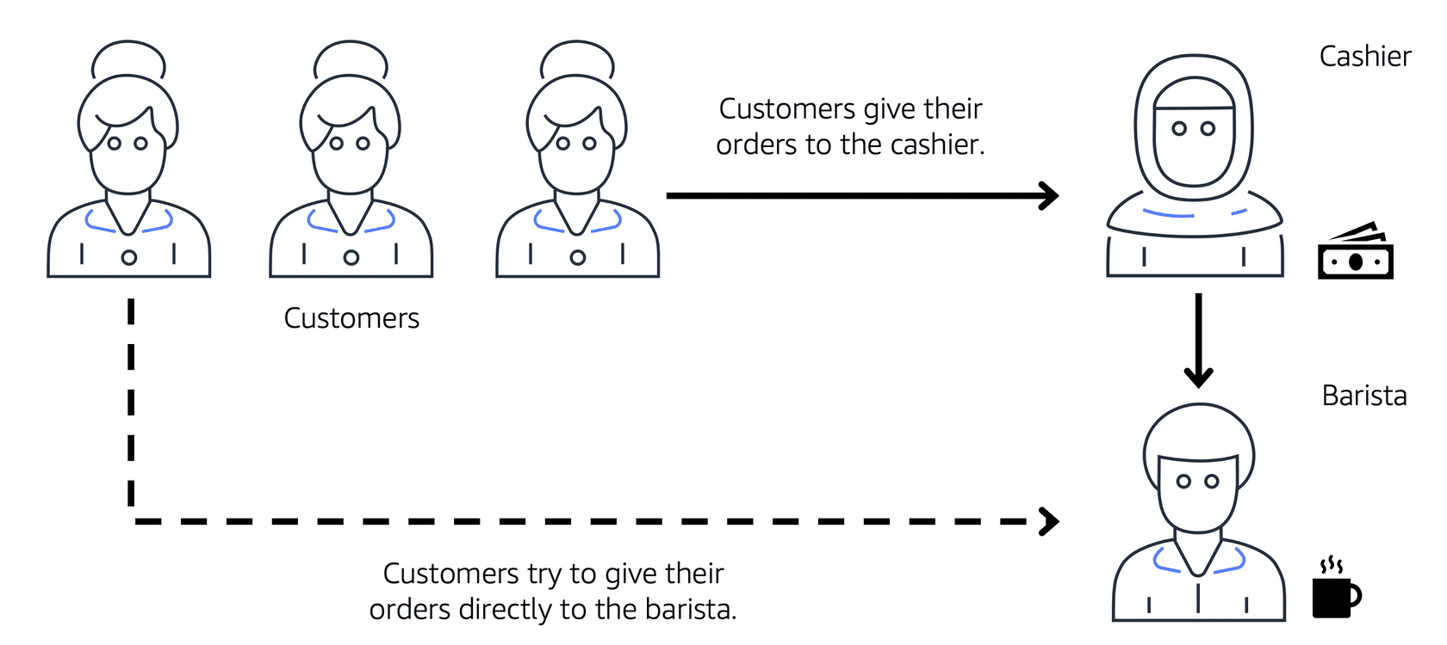

To fix this, the owners of the coffee shop divide the counter area by placing the cashier and the barista in separate workstations. The cashier’s workstation is public facing and designed to receive customers. The barista’s area is private. The barista can still receive orders from the cashier but not directly from customers.

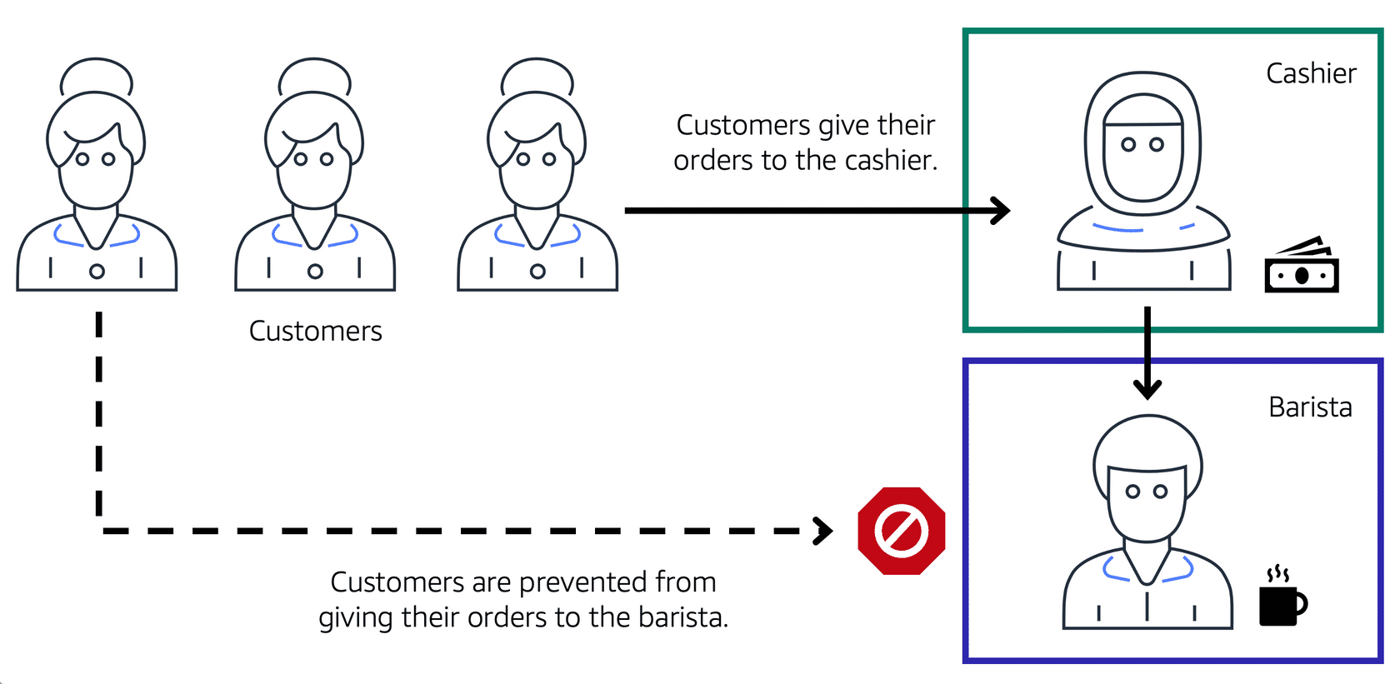

This is similar to how you can use AWS networking services to isolate resources and determine exactly how network traffic flows.

In the coffee shop, you can think of the counter area as a VPC. The counter area divides into two separate areas for the cashier’s workstation and the barista’s workstation. In a VPC, **subnets** are separate areas that are used to group together resources.

**Subnets**

A subnet is a section of a VPC in which you can group resources based on security or operational needs. Subnets can be public or private.

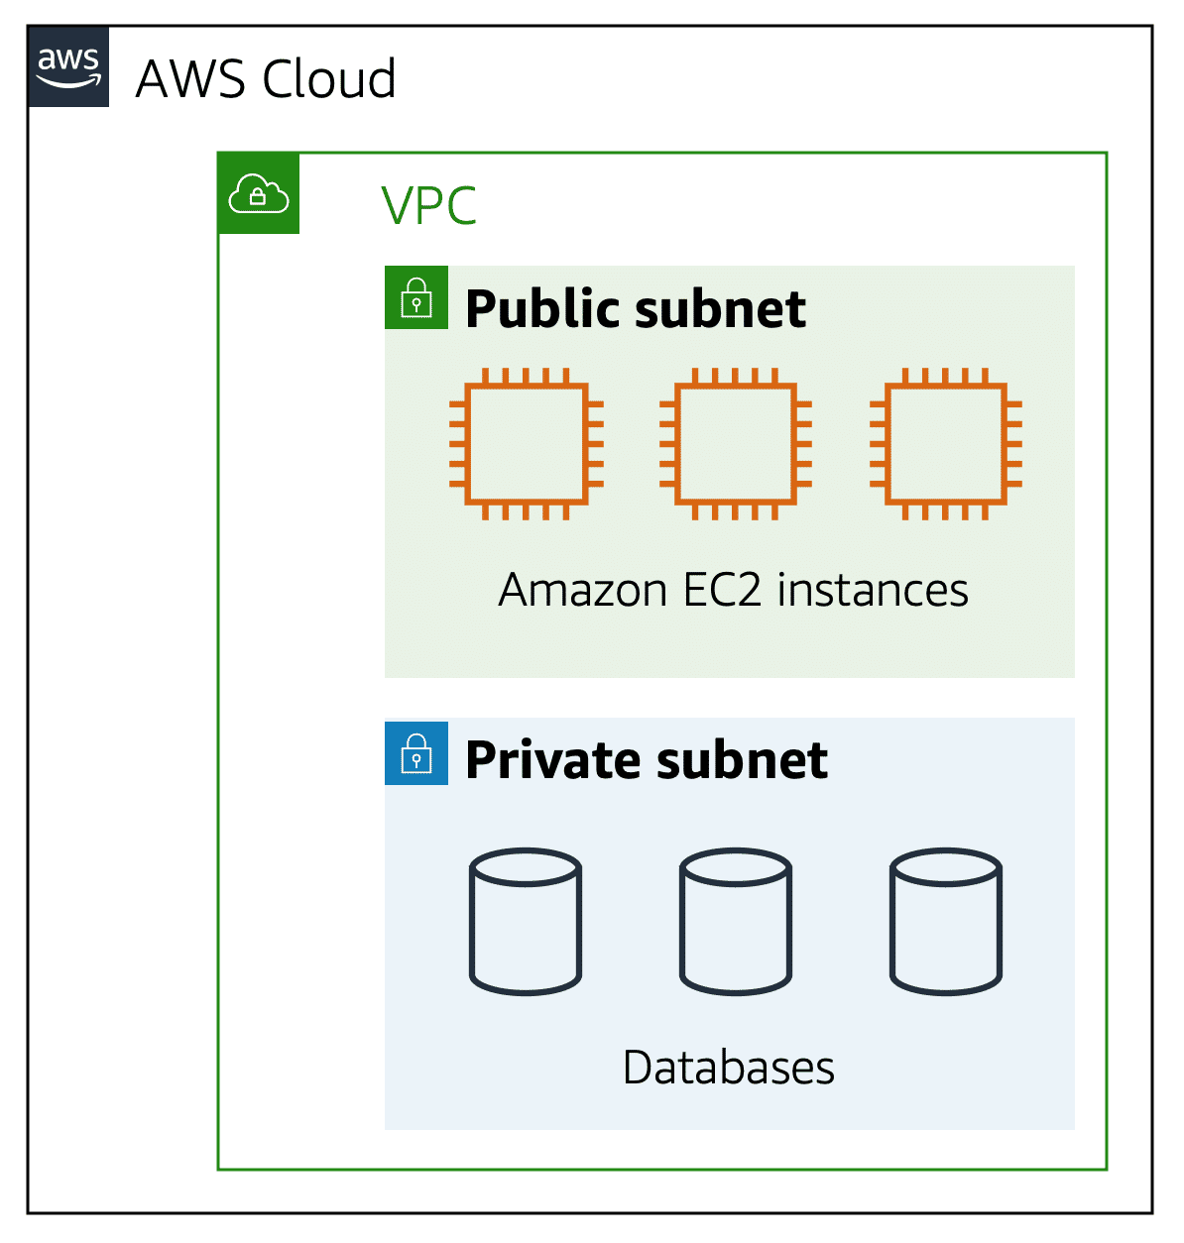

**Public subnets** contain resources that need to be accessible by the public, such as an online store’s website.

**Private subnets** contain resources that should be accessible only through your private network, such as a database that contains customers’ personal information and order histories.

In a VPC, subnets can communicate with each other. For example, you might have an application that involves Amazon EC2 instances in a public subnet communicating with databases that are located in a private subnet.

**Network traffic in a VPC**

When a customer requests data from an application hosted in the AWS Cloud, this request is sent as a packet. A **packet** is a unit of data sent over the internet or a network.

It enters into a VPC through an internet gateway. Before a packet can enter into a subnet or exit from a subnet, it checks for permissions. These permissions indicate who sent the packet and how the packet is trying to communicate with the resources in a subnet.

The VPC component that checks packet permissions for subnets is a [**network access control list (ACL)**](https://docs.aws.amazon.com/vpc/latest/userguide/vpc-network-acls.html). Ref Page 115 Pdf

**Network access control lists (ACLs)**

A network access control list (ACL) is a virtual firewall that controls inbound and outbound traffic at the subnet level.

For example, step outside of the coffee shop and imagine that you are in an airport. In the airport, travelers are trying to enter into a different country. You can think of the travelers as packets and the passport control officer as a network ACL. The passport control officer checks travelers’ credentials when they are both entering and exiting out of the country. If a traveler is on an approved list, they are able to get through. However, if they are not on the approved list or are explicitly on a list of banned travelers, they cannot come in.

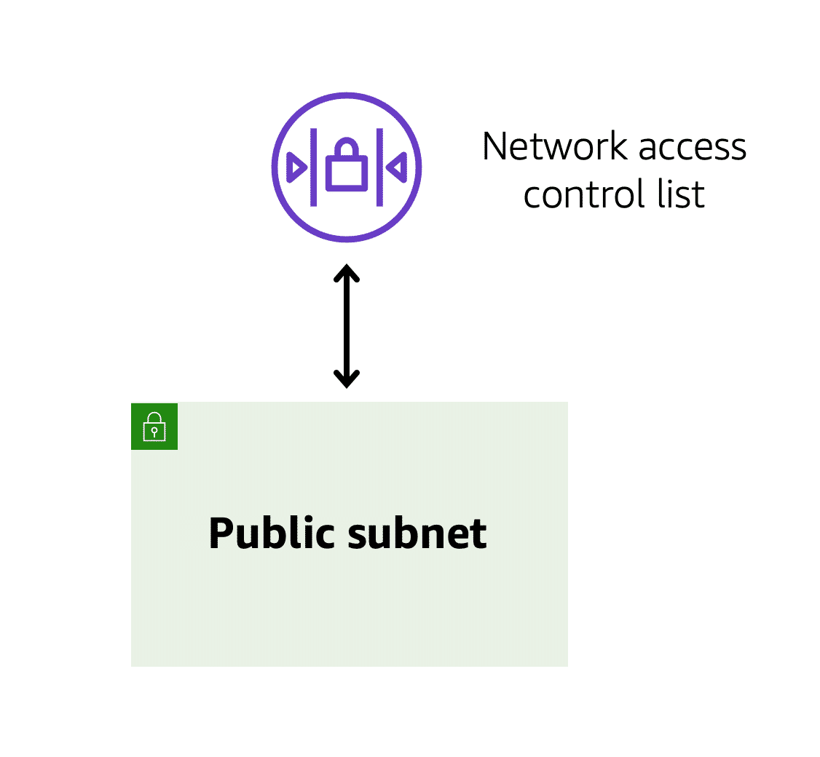

Each AWS account includes a default network ACL. When configuring your VPC, you can use your account’s default network ACL or create custom network ACLs.

By default, your account’s default network ACL allows all inbound and outbound traffic, but you can modify it by adding your own rules. For custom network ACLs, all inbound and outbound traffic is denied until you add rules to specify which traffic to allow. Additionally, all network ACLs have an explicit deny rule. This rule ensures that if a packet doesn’t match any of the other rules on the list, the packet is denied.

**Stateless packet filtering**

Network ACLs perform **stateless** packet filtering. They remember nothing and check packets that cross the subnet border each way: inbound and outbound.

Recall the previous example of a traveler who wants to enter into a different country. This is similar to sending a request out from an Amazon EC2 instance and to the internet.

When a packet response for that request comes back to the subnet, the network ACL does not remember your previous request. The network ACL checks the packet response against its list of rules to determine whether to allow or deny.

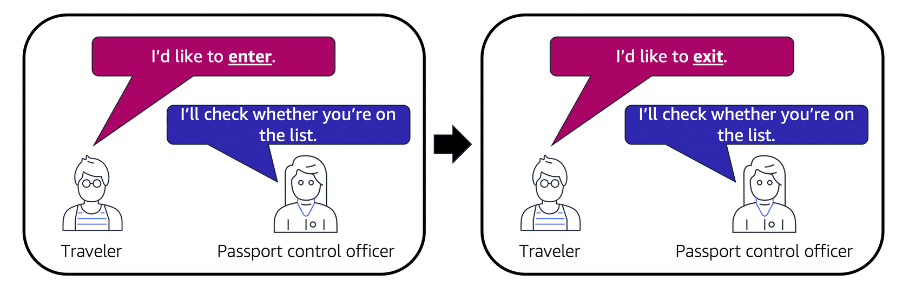

After a packet has entered a subnet, it must have its permissions evaluated for resources within the subnet, such as Amazon EC2 instances.

The VPC component that checks packet permissions for an Amazon EC2 instance is a [**security group**](https://docs.aws.amazon.com/vpc/latest/userguide/VPC_SecurityGroups.html). Ref. Page 256 Pdf

**Security groups**

A security group is a virtual firewall that controls inbound and outbound traffic for an Amazon EC2 instance.

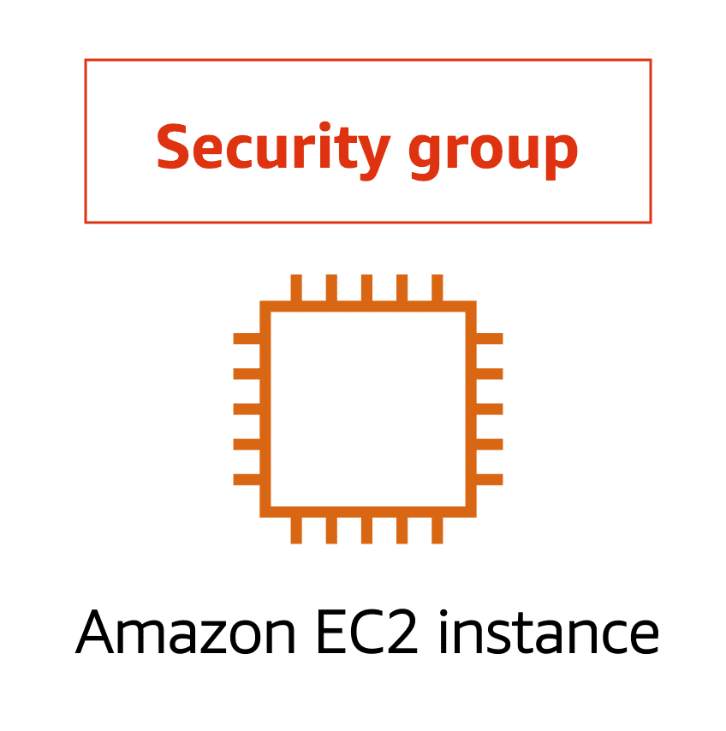

By default, a security group denies all inbound traffic and allows all outbound traffic. You can add custom rules to configure which traffic to allow or deny.

For this example, suppose that you are in an apartment building with a door attendant who greets guests in the lobby. You can think of the guests as packets and the door attendant as a security group. As guests arrive, the door attendant checks a list to ensure they can enter the building. However, the door attendant does not check the list again when guests are exiting the building

If you have multiple Amazon EC2 instances within a subnet, you can associate them with the same security group or use different security groups for each instance.

**Stateful packet filtering**

Security groups perform **stateful** packet filtering. They remember previous decisions made for incoming packets.

Consider the same example of sending a request out from an Amazon EC2 instance to the internet.

When a packet response for that request returns to the instance, the security group remembers your previous request. The security group allows the response to proceed, regardless of inbound security group rules.

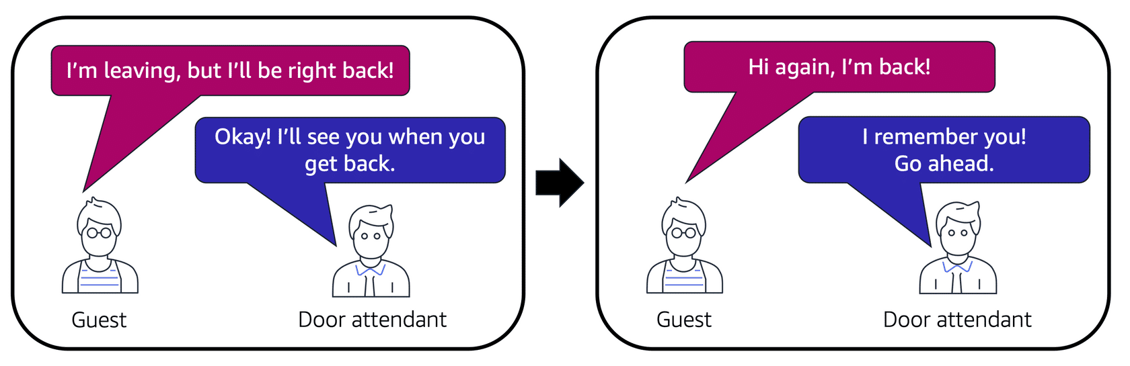

Both network ACLs and security groups enable you to configure custom rules for the traffic in your VPC. As you continue to learn more about AWS security and networking, make sure to understand the differences between network ACLs and security groups.

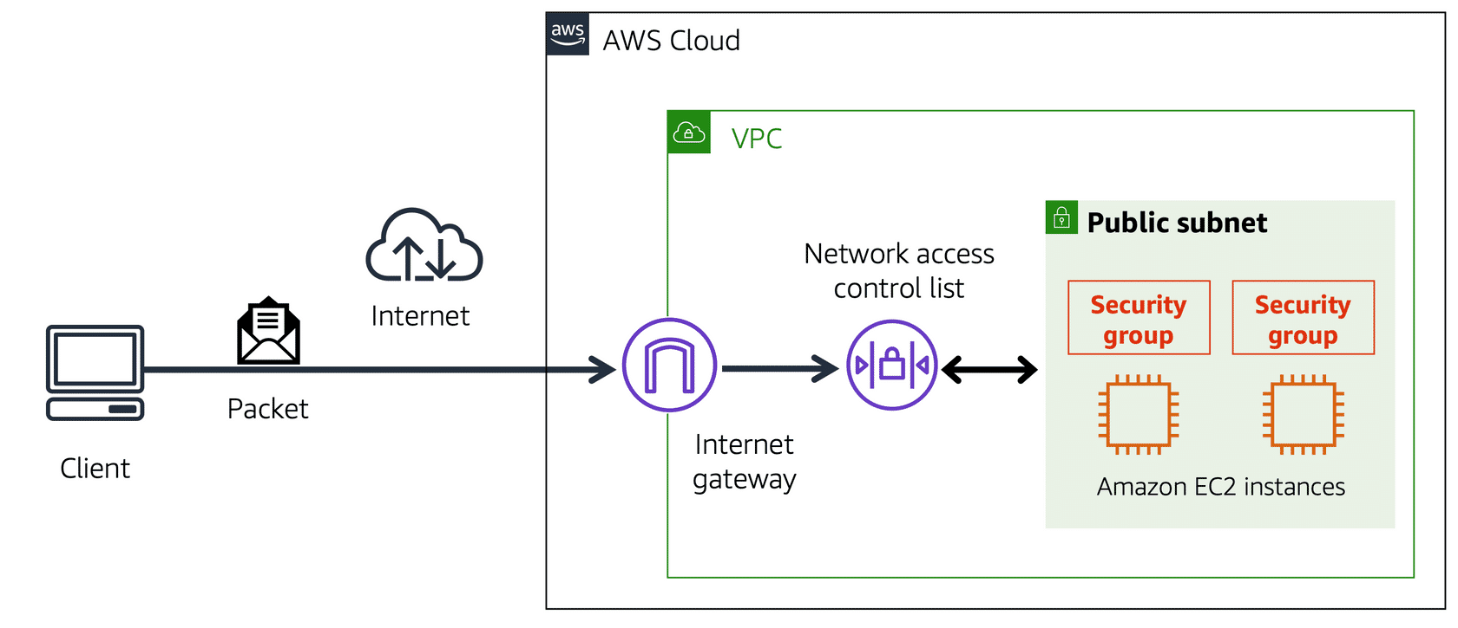

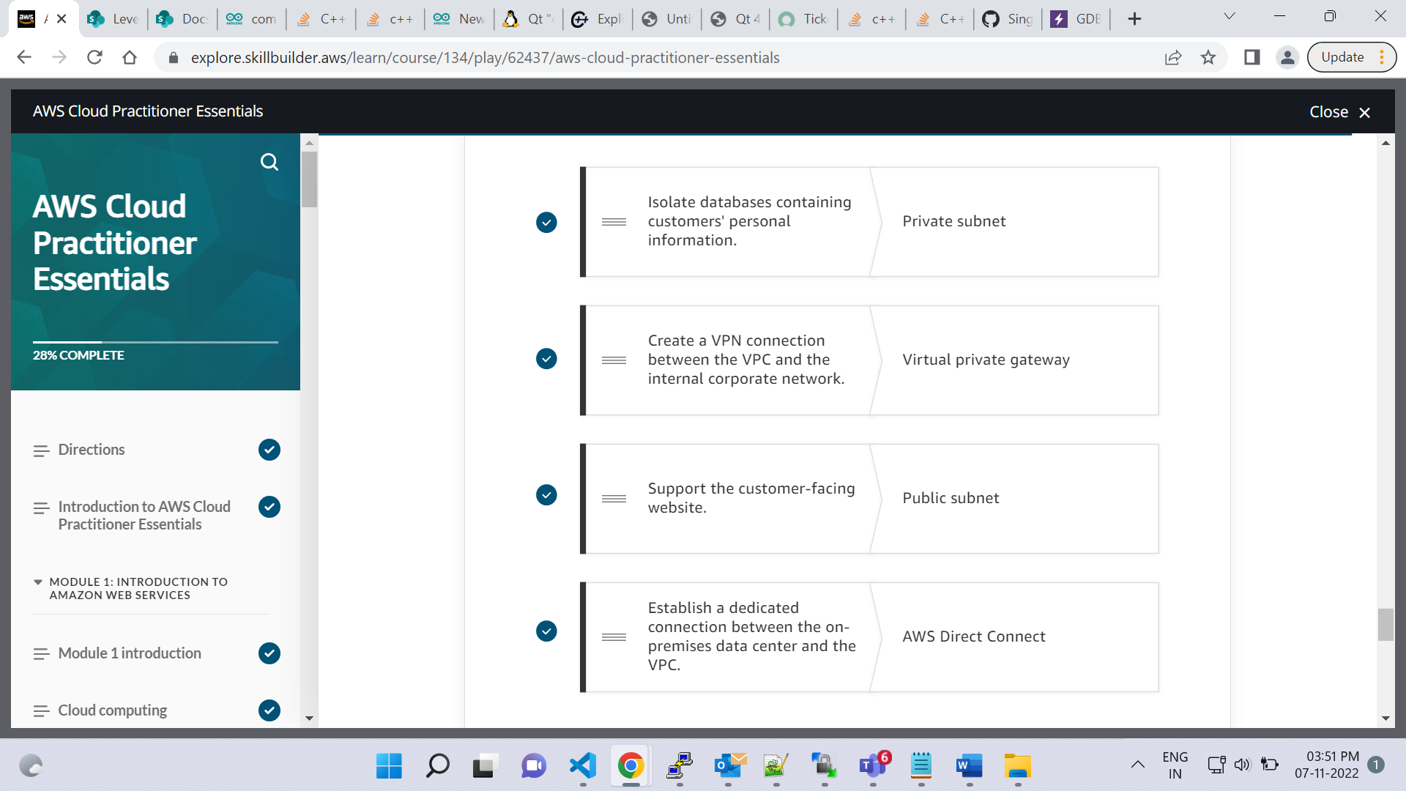

The correct response option is**It is stateless and allows all inbound and outbound traffic**.

Network access control lists (ACLs) perform **stateless**packet filtering. They remember nothing and check packets that cross the subnet border each way: inbound and outbound.

Each AWS account includes a default network ACL. When configuring your VPC, you can use your account’s default network ACL or create custom network ACLs.

By default, your account’s default network ACL allows all inbound and outbound traffic, but you can modify it by adding your own rules. For custom network ACLs, all inbound and outbound traffic is denied until you add rules to specify which traffic should be allowed. Additionally, all network ACLs have an explicit deny rule. This rule ensures that if a packet doesn’t match any of the other rules on the list, the packet is denied.

# Global networking

**Video transcript**

–

We've been talking a lot about how you interact with your AWS infrastructure. But how do your customers interact with your AWS infrastructure? Well, if you have a website hosted at AWS, then customers usually enter your website into their browser, hit Enter, some magic happens, and the site opens up.

But how does this magic work? Well, just like this magic coin that I have here, you know, you take a bite, and it's, it's back. Well, not quite like that, but I'm going to take you through two services, which would help in the website case. The first one being Route 53. Route 53 is AWS's domain name service, or DNS, and it's highly available and scalable. But wait, what is DNS, you say? Think of DNS as a translation service. But instead of translating between languages, it translates website names into IP, or Internet Protocol, addresses that computers can read.

For example, when we enter a website address into our browser, it contacts Route 53 to obtain the IP address of the site, say, 192.1.1.1, then it routes your computer or browser to that address. If we go further, Route 53 can direct traffic to different endpoints using several different routing policies, such as latency-based routing, geolocation DNS, geoproximity, and weighted round robin. If we take geolocation DNS, that means we direct traffic based on where the customer is located. So traffic coming from say North America is routed to the Oregon Region, and traffic in Ireland is routed to the Dublin Region, as an example.

You can even use Route 53 to register domain names, so you can buy and manage your own domain names right on AWS.

Speaking of websites, there is another service which can help speed up delivery of website assets to customers, Amazon CloudFront. If you remember, we talked about Edge locations earlier in the course, these locations are serving content as close to customers as possible, and one part of that, is the content delivery network, or CDN. For those who need reminding, a CDN is a network that helps to deliver edge content to users based on their geographic location.

If we go back to our North America versus Ireland example, say we have a user in Seattle, and they want to access a website, to speed this up, we host the site in Oregon, and we deploy our static web assets, like images and GIFs in CloudFront in North America. This means they get content delivered as close to them as possible, North America in this case, when they access the site. But for our Irish users, it doesn't make sense to deliver those assets out of Oregon, as the latency is not favorable. Thus we deploy those same static assets in CloudFront, but this time in the Dublin Region. That means they can access the same content, but from a location closer to them, which in turn improves latency.

I hope you're content after learning about these two services. Thanks for following along, and I'm going to disappear just like this red cloth. Tada!

**Domain Name System (DNS)**

Suppose that AnyCompany has a website hosted in the AWS Cloud. Customers enter the web address into their browser, and they are able to access the website. This happens because of **Domain Name System (DNS)** resolution. DNS resolution involves a customer DNS resolver communicating with a company DNS server.

You can think of DNS as being the phone book of the internet. DNS resolution is the process of translating a domain name to an IP address.

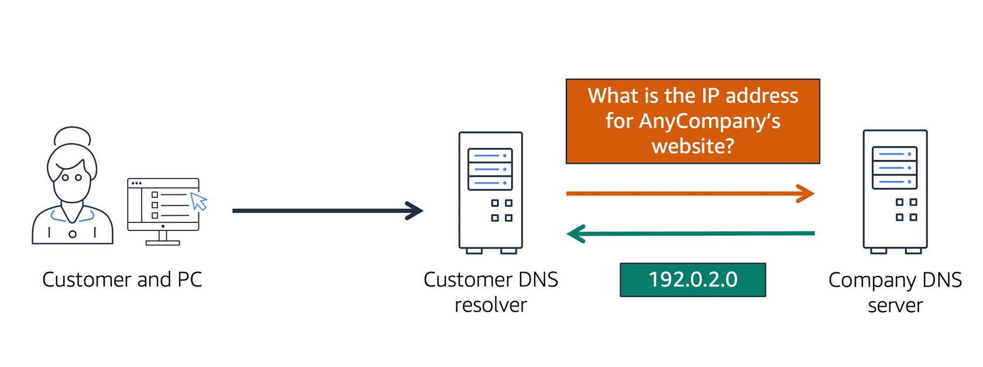

For example, suppose that you want to visit AnyCompany’s website.

* 1

1

When you enter the domain name into your browser, this request is sent to a customer DNS resolver.

* 2

2

The customer DNS resolver asks the company DNS server for the IP address that corresponds to AnyCompany’s website.

* 3

3

The company DNS server responds by providing the IP address for AnyCompany’s website, 192.0.2.0.

**Amazon Route 53**

[**Amazon Route 53**](https://aws.amazon.com/route53) is a DNS web service. It gives developers and businesses a reliable way to route end users to internet applications hosted in AWS.

Amazon Route 53 connects user requests to infrastructure running in AWS (such as Amazon EC2 instances and load balancers). It can route users to infrastructure outside of AWS.

Another feature of Route 53 is the ability to manage the DNS records for domain names. You can register new domain names directly in Route 53. You can also transfer DNS records for existing domain names managed by other domain registrars. This enables you to manage all of your domain names within a single location.

In the previous module, you learned about Amazon CloudFront, a content delivery service. The following example describes how Route 53 and Amazon CloudFront work together to deliver content to customers.

**Example: How Amazon Route 53 and Amazon CloudFront deliver content**

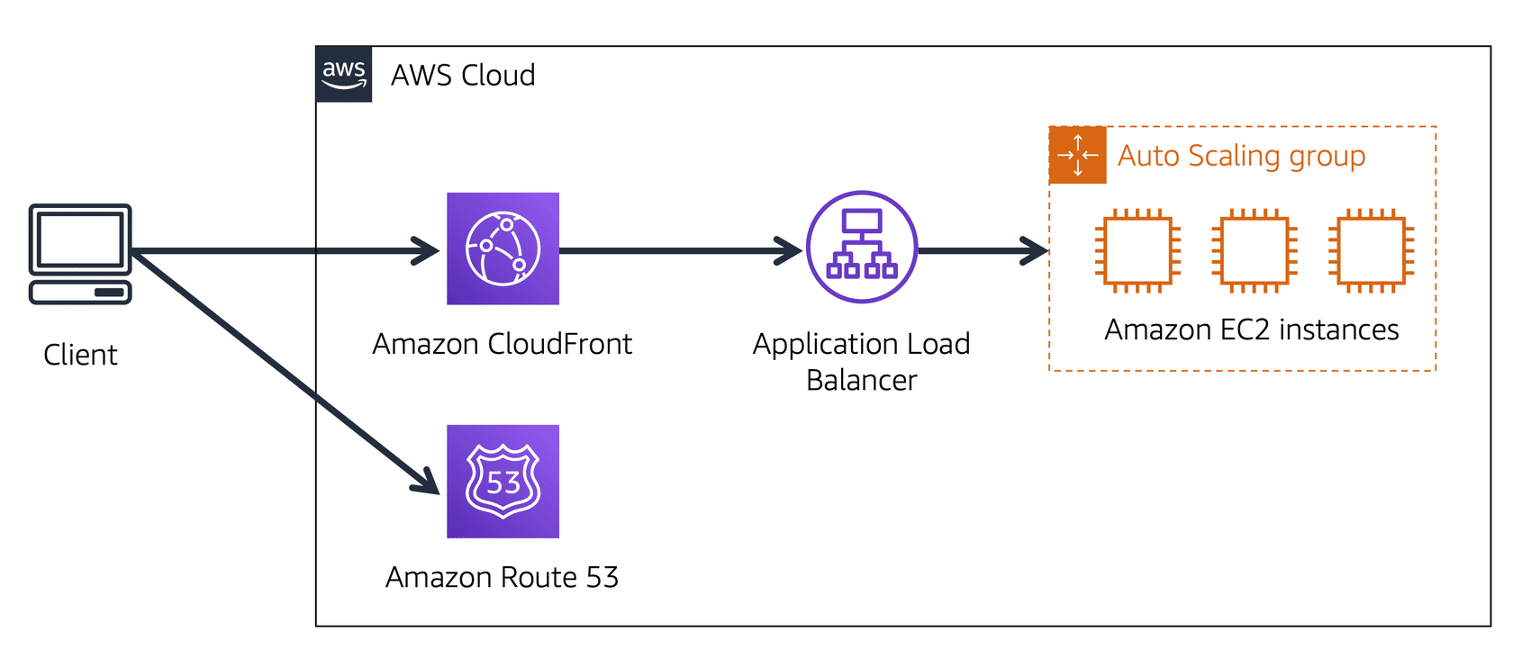

Suppose that AnyCompany’s application is running on several Amazon EC2 instances. These instances are in an Auto Scaling group that attaches to an Application Load Balancer.

* 1

1

A customer requests data from the application by going to AnyCompany’s website.

* 2

2

Amazon Route 53 uses DNS resolution to identify AnyCompany.com’s corresponding IP address, 192.0.2.0. This information is sent back to the customer.

* 3

3

The customer’s request is sent to the nearest edge location through Amazon CloudFront.

* 4

4

Amazon CloudFront connects to the Application Load Balancer, which sends the incoming packet to an Amazon EC2 instance.

The correct response option is **Translating a domain name to an IP address**.

For example, if you want to visit AnyCompany’s website, you enter the domain name into your PC and this request is sent to a DNS server. Next, the DNS server asks the web server for the IP address that corresponds to AnyCompany’s website. The web server responds by providing the IP address for AnyCompany’s website, 192.0.2.0.

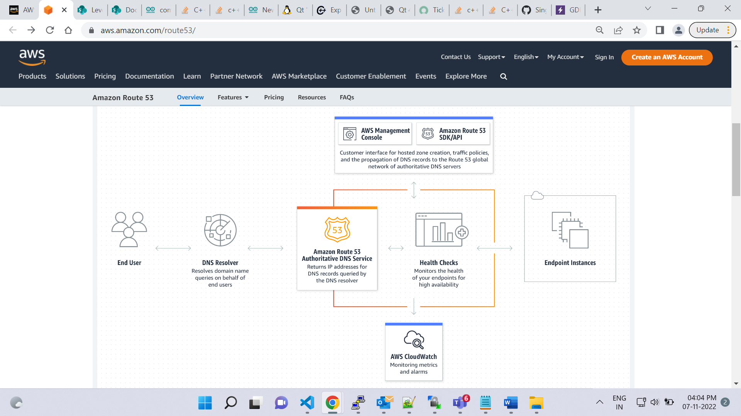

**Module 4 summary**

In Module 4, you learned about the following concepts:

* Structuring and connecting to a VPC
* Securing VPC resources with network access control lists and security groups
* Using Amazon Route 53 and Amazon CloudFront to deliver content
* The correct response option is **Place the Amazon EC2 instances in a public subnet and the Amazon RDS databases instances in a private subnet**.
* A **subnet**is a section of a VPC in which you can group resources based on security or operational needs. Subnets can be public or private.
* Public subnets contain resources that need to be accessible by the public, such as an online store’s website.
* Private subnets contain resources that should be accessible only through your private network, such as a database that contains customers’ personal information and order histories.

The correct response option is **AWS Direct Connect**.

The other response options are incorrect because:

* A private subnet is a section of a VPC in which you can group resources that should be accessed only through your private network. Although it is private, it is not used for establishing a connection between a data center and AWS.
* DNS stands for Domain Name System, which is a directory used for matching domain names to IP addresses.
* A virtual private gateway enables you to create a VPN connection between your VPC and a private network, such as your company’s data center. Although this connection is private and encrypted, it travels through the public internet, not through a dedicated connection.

The correct response option is **Security groups are stateful and deny all inbound traffic by default**.

Security groups are stateful. This means that they use previous traffic patterns and flows when evaluating new requests for an instance.

By default, security groups deny all inbound traffic, but you can add custom rules to fit your operational and security needs.